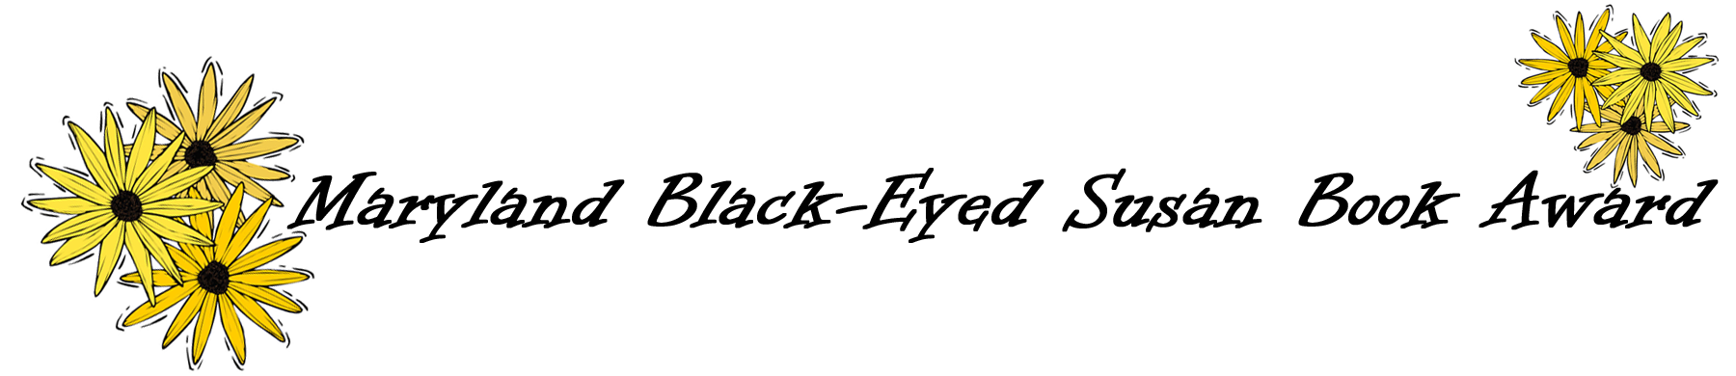
2020-2021
And the winner is…
The votes have been counted and thousands of students from across the state have selected their favorite books as part of the Maryland Black-Eyed Susan Book Award program. The student selections are:
Picture Book – Zombies Don’t Eat Veggies! by Megan Lacera, illustrated by Jorge Lacera
Grades 4-6 – A Wolf Called Wander by Rosanne Perry
Graphic Novels Grades 4-6 – Best Friends by Shannon Hale illustrated by LeUyen Pham
Grades 6-9 – Allies by Alan Gratz & All the Impossible Things by Lindsay Lackey
Graphic Novels Grades 6-9 – White Bird by R. J. Palacio
High School – What If It’s Us by Becky Albertalli and Adam Silvera

Congratulations to our winning authors, illustrators, and publishers and to the students, teachers, and librarians who every year make the program such a resounding success.
The Results
Wondering how your favorite book did in student voting? The following charts list the books in descending order beginning with the top vote getter. In deference to our authors, publishers, and especially the student voters whose books did not capture top honors, we do not publish numbers of votes.
Picture Books
Zombies Don’t Eat Veggies!
Linus the Little Yellow Pencil
Rescue & Jessica: A Life-Changing Friendship
Sulwe
Ninita’s Big World: The True Story of a Deaf Pygmy Marmoset
The Crayon Man: The True Story of the Invention of Crayola Crayons
When Grandma Gives You a Lemon Tree
Facts vs. Opinions vs. Robots
Just Ask! Be Different, Be Brave, Be You
The Proudest Blue: A Story of Hijab and Family
Me and the Sky: Captain Beverly Bass, Pioneering Pilot
The Remember Balloons
Her Right Foot
Ruby Finds a Worry
Sweety

Grades 4-6
A Wolf Called Wander
Words on Fire
Song for a Whale
Operation Frog Effect
The Trail
Unteachables
Guest: A Changeling Tale
The Light Jar
The Unsung Hero of Birdsong USA
Finding Langston

Graphic Novels Grades 4-6
Best Friends
Camp
Cardboard Kingdom
Stargazing
Glitch
This Was Our Pact
Hicotea / Nico Bravo and the Hound of Hades
The Dugout: The Zombie Steals Home
Rocket to the Moon

Grades 6-9
Allies / All the Impossible Things
The Remarkable Journey of Coyote Sunrise
Maybe He Just Likes You
It Wasn't Me
Charlie Thorne and the Last Equation
The Dollar Kids
Marcus Vega Doesn't Speak Spanish
The Missing Piece of Charlie O' Reilly / Journey of the Pale Bear

Graphic Novels Grades 6-9
White Bird
Teen Titans: Raven
Almost American Girl
Mooncakes
Animus
Persephone
Grimoire Noir
Witch Hat Atelier Vol. 1 / Sleepless: Vol. 1
Operatic

High School
What If It's Us
Aurora Rising
Two Can Keep a Secret
With the Fire on High / They Called Us Enemy
Laura Dean Keeps Breaking Up With Me
Frankly in Love
The Last to Let Go
Ordinary Hazards / A Very Large Expanse of Sea

