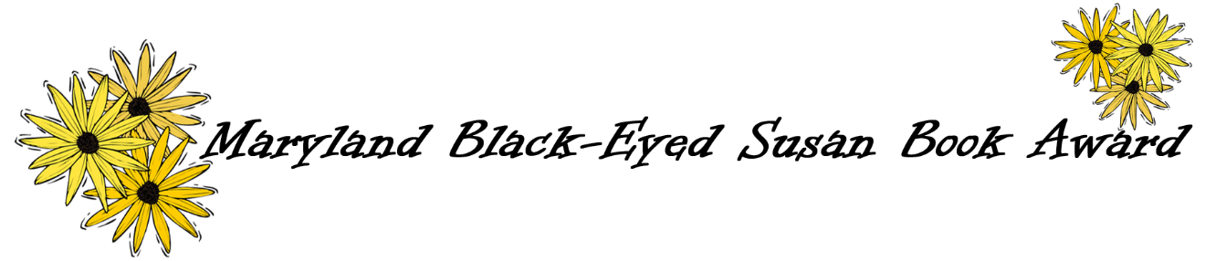
Picture Book Voting Tally
2019-2020

REMEMBER: EVERY STUDENT VOTE COUNTS!
Title | Grades (Optional) | Totals
Do Not Lick This Book: It’s Full of Germs

Carmela Full of Wishes

The Rabbit Listened

A House That Once Was

We Don’t Eat Our Classmates!

I Walk with Vanessa: A Story About a Simple Act of Kindness

Drawn Together

Geraldine

The Brilliant Deep: Rebuilding the World’s Coral Reefs

Inky’s Amazing Escape: How a Very Smart Octopus Found His Way Home

Girl Running: Bobbi Gibb and the Boston Marathon

Are You Scared, Darth Vader?

A Place for Pluto

Between the Lines: How Ernie Barnes Went from the Football Field to the Art Gallery

The Day You Begin

Person Completing Form: | Position:
School: | County:
Address:
Phone:
Email:

If using US Postal Service, tally must be postmarked no later than April 25, 2020.

Please send to:
Maryland Black-Eyed Susan Book Award
c/o Dedra Van Gelder
2207 Garden Lane
Bryans Road, MD 20616

